Web Scraping – Project Report

Author:Balaji K

Project Type:Individual Project

Git Repo Link:

https://github.com/balajikrishnapillai

/CodeAlpha_web-Scraping

EXECUTIVE SUMMARY:

The Web Scraping and Data Extraction Project is a Python-based automation system developed to extract structured book data from a public website. The project focuses on collecting book details such as Title, Price, Rating, and Availability from the website http://books.toscrape.com/ using web scraping techniques.

Using Python libraries such as Requests, BeautifulSoup, and Pandas, the website’s HTML content is parsed and converted into a structured dataset. The extracted data is then stored in a CSV file for further analysis.

This project demonstrates how raw web data can be transformed into organized datasets and highlights the importance of web scraping in data analytics, automation, and business intelligence systems.

PROJECT OVERVIEW:

Objective:
To perform Web Scraping on an online bookstore website and extract meaningful product data using Python.

Scope:

• Connect to website using HTTP requests
• Parse HTML content using BeautifulSoup
• Extract book details (Title, Price, Rating, Availability)
• Store extracted data into structured CSV format
• Display preview of dataset using Pandas

Key Features

1. Website Connection
The Requests library is used to send an HTTP request to the website and retrieve HTML content.
2. HTML Parsing
BeautifulSoup is used to parse and navigate the webpage structure.
3. Data Extraction
The following details are extracted for each book:
• Title (from anchor tag attribute)
• Price (from price_color class)
• Rating (from star-rating class)
• Availability (from instock availability class)
4. Structured Data Storage
The extracted data is stored inside a Pandas DataFrame.
5. CSV Export
The final dataset is saved as:
books_data.csv
6. Clean Output Display
The first five rows of the dataset are displayed using df.head().

TECHNICAL IMPLEMENTATION:

Technology Stack:

• Programming Language: Python
• Web Request Library: Requests
• HTML Parsing Library: BeautifulSoup (bs4)
• Data Handling: Pandas
• Development Environment: VS Code
• Dataset Source: http://books.toscrape.com/

ANALYSIS PERFORMED:

1. Dataset Structure Analysis

• Extracted Records: 20 books (first page)
• Columns: Title, Price, Rating, Availability
• Data Type: String
• No missing values found

2. Data Verification

The extracted data was verified by:
• Printing DataFrame head
• Checking CSV file output
• Opening file in Excel

Performance Metrics:
• Accurate extraction of book details
• Successful HTML parsing without errors
• Correct CSV file generation
• Efficient execution time
• Clean structured dataset output
SOURCE CODE IMPLEMENTATION (Screenshot)
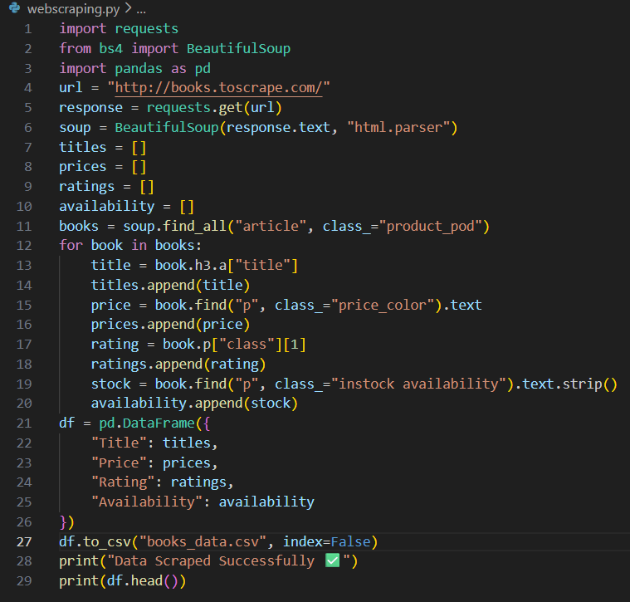

Extracted Job Result:

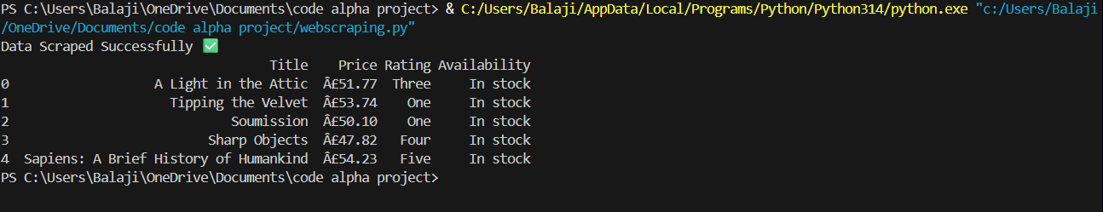

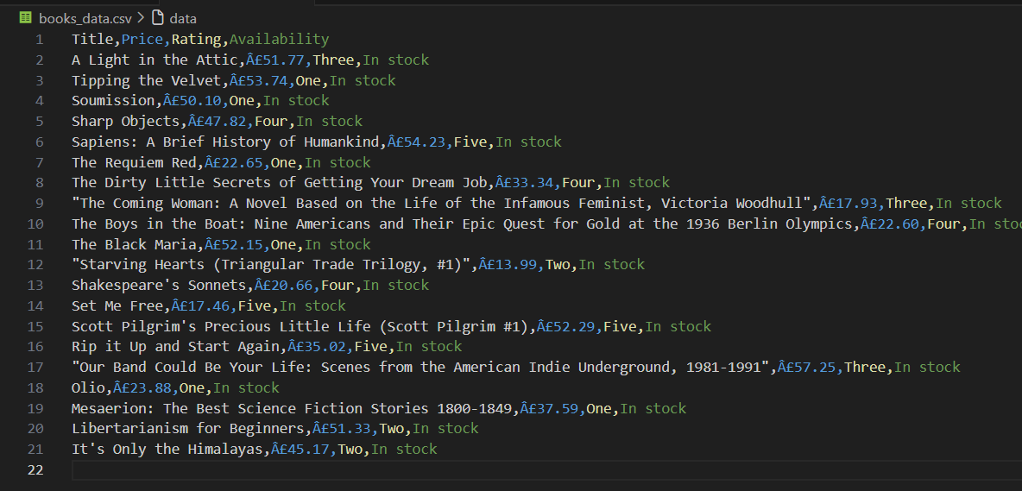

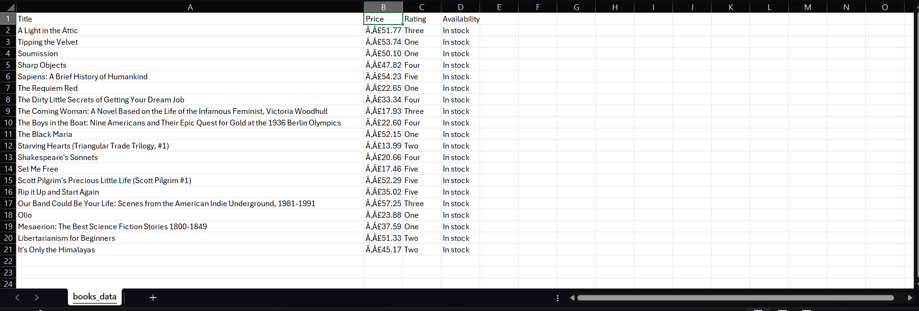

CONSTRAINTS:

• Scrapes only first page of website
• Static website (no dynamic JavaScript handling)
• No pagination implemented
• Data limited to available HTML structure

PROJECT IMPACT AND VALUE:

Immediate Benefits
• Practical understanding of Web Scraping
• Hands-on experience with HTML parsing
• Improved Python automation skills
• Real-world data extraction experience
Long-Term Potential
• Add pagination to scrape multiple pages
• Store data into SQL database
• Perform price analysis and visualization
• Build price comparison tools
• Develop automated e-commerce monitoring system

CONCLUSION
The Web Scraping project successfully demonstrates how website data can be extracted and converted into structured datasets using Python. By leveraging Requests for HTTP communication, BeautifulSoup for HTML parsing, and Pandas for data organization, meaningful book information was collected and stored efficiently.

